Prev leak innovation

Description
Project Status:
TPS recycles plastic material to manufacture polymer manhole covers that are then fitted with an ultra sensor, sigfox module, and microcontroller to detect and report sewage blockage on our app. This allows communities, businesses, and municipalities to have an early detection system that notifies them of sewage blockages that cause pollution, health risks, and contamination of water resources as a result of overflow.
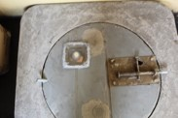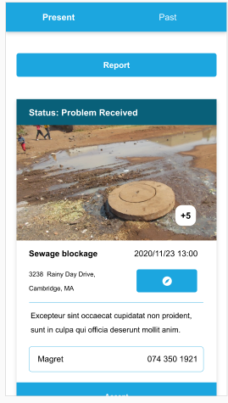
South Africa suffers from sewage pollution as a result of repeat blockages. This happens because: 1.Municipal agencies use a telephonic system which causes delays of up 2 weeks. 2.Lack of sanitation infrastructure maintenance. This impacts on human health, economic productivity, the quality of ambient freshwater resources, and ecosystems.
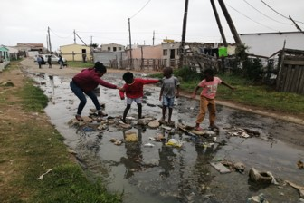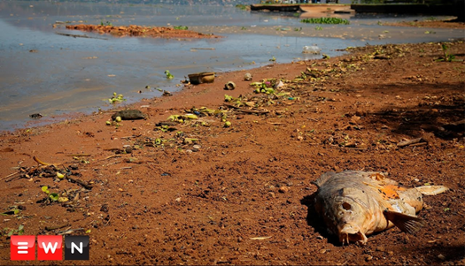
The Goal of this is:
1.To empower clients with the digital tools and smart early detection systems to ward off blocked sewers and improve reporting of water leaks to save water and keep our environment clean from sewer pollution.
2.Improve the quality-of-service delivery by automating the response.
3.Generation of data to help identify potential “hot-spots” for better planning.
4. Has locking mechanism and tracking system to prevent theft of manhole covers for the Schools.
History:
In 2019 we piloted a project using our 1st prototype sensor and Held a meeting with the Zola community who through a contribution scheme employed 3 locals as servicemen to receive SMS and email notification of blocked sewer where prev leak was installed.
Recent accolades:
We won the CPSI Ministerial award 2020 after applying for the community innovation category.
Link: https://t.co/lHWWMPVy6i?amp=1
Solving the problem:
The most valuable aspect of this project was that the community of Zola were able to solve their own problems of sewage blockages using technology and came together by contributing money to hire locals who responded to unblock seer lines before they can overflow. 1. This limited human contact with sewer because locals always arrived whilst the blocked sewer was still in containment. 2. Limited pollution of overflowing sewer that brought health risk and contamination of water sources.
Expected impact
ENVIRONMENTAL BENEFIT.
Biodiversity conservation. By reducing the amount of sewage overflows that end up polluting our environment, wetlands, streams used by people living in rural areas and eventually polluting the ocean.
Link of sewage problem in South Africa: https://youtu.be/pYO-01xLnz8
Water and biodiversity conservation. Wastewater Pollution prevention.
Economic benefit.
Youth employment creation who use technology to serve their own community responding to unblock sewer manholes before they can overflow as a result of early detection.
Social and sustainable benefit.
Community self-sustainability and beneficiation where communities can be responsible to self-manage their own wastewater problems and employ their own to respond limiting dependency on government service delivery thus reducing omission of water service providers trucks having to drive responding to local blockage issues.
Social cohesion.
In terms of task relation of each community, who will be responsible to all stakeholders involved by having to submit their sewage overflow footprint reports of how many blockages were prevented using (Technology) prev leak solution.
Link showing locals responding to unblock sewage: https://youtu.be/c20tXl9pJWk
Covid-19 response and water illness future pandemic.
Covid 19 is now found in wastewater (Sewage). Therefore, human contact with overflowing sewer can increase covid 19 infection rate drastically. Because our solution is an early detection system when there is a blocked sewer, locals who respond arrive whilst the sewer is still contained inside the sewer and use unblocking tools to unblock it before it overflows, reducing human contact with sewer before it can overflow outside the manholes. Therefore communities can save their own lives as a result of preventing human contact from covid 19 infested sewer.
Link showing proof of covid19 infested sewer: https://youtu.be/DqemeEFBceU
Website
www.technologicalplumbingsolutions.co.za
link to IOL news
https://www.iol.co.za/technology/software-and-internet/from-groundbreaking-apps-to-retractable-umbrella-young-sa-innovators-showcase-products-f0c637ca-cffe-4c39-9044-46f190103360

