CSIR TENDER DOCUMENTATION

Expression of Interest (EOI)

for
B-L.I.F.E. Manufacturing, Marketing, Distribution and
Support

EOI No. CRFP_EOI_002_30/11/2021

Date of Issue | Monday, xx/xx/2021
Closing Date | + 3 Weeks
Place | Online only submission at tender@csir.co.za  If the size of the documents exceed 30MB, send multiple emails. Use the EOI number and description as the subject on the email.
Enquiries | Strategic Procurement Unit | E-mail: tender@csir.co.za
CSIR business hours | 08h00 – 16h30
Category | Professional

Table of Contents
1 INTRODUCTION 3
2 INVITATION 3
3 BACKGROUND 3
4 ELIMINATION CRITERIA 10
5 NATIONAL TREASURY CENTRAL SUPPLIER DATABASE REGISTRATION 11
6 VENUE FOR PROPOSAL SUBMISSION 12
7 EOI PROGRAMME 12
8 SUBMISSION OF RESPONSES 12
9 DEADLINE FOR SUBMISSION 12
10 EVALUATION PROCESS 13
11 ENQUIRIES AND CONTACT WITH THE CSIR 13
13 COST OF EXPRESSION OF INTEREST 13
14 CORRECTNESS OF RESPONSES 13
15 VERIFICATION OF DOCUMENTS 14
16 SUB-CONTRACTING 14
17 ENGAGEMENT OF CONSULTANTS 14
18 TRAVEL EXPENSES 14
19 ADDITIONAL TERMS AND CONDITIONS 15
20 CSIR RESERVES THE RIGHT TO 15
21 DISCLAIMER 16

1 INTRODUCTION

The Council for Scientific and Industrial Research (CSIR) is one of the leading scientific research and technology development organisations in Africa. In partnership with national and international research and technology institutions, CSIR undertakes directed and multidisciplinary research and technology innovation that contributes to the improvement of the quality of life of South Africans. The CSIR’s main site is in Pretoria while it is represented in other provinces of South Africa through regional offices.

2 INVITATION

The B-L.I.F.E. system is a CSIR developed BiPAP device, specifically intended to assist patients experiencing respiratory distress due to Covid-19 infection. As a simple ventilation enhancement system it is designed to meet the demand for early stage patients experiencing respiratory difficulty and requiring low level assistance of oxygen enhanced respiratory air.

The B-L.I.F.E. system is ready to be manufactured and marketed in South Africa and beyond, with the aim of creating and expanding manufacturing activity and associated job creation. The current EoI call is targeted at new or existing SMMEs performing the discrete manufacturing in this sector to grow and expand manufacturing capacity to meet market demands.

(Note: purchasing of equipment for enterprises or direct monetary support of enterprises is not provided for in this call.)

3 BACKGROUND

The CSIR BiPAP Lung Inspiratory Flow Enabler, (B-L.I.F.E.) is a non-invasive ventilation system (NVS) which supplies an adjustable pressurized mixture of air and oxygen to the patient through a mask or hood. The pressurized gas helps the patient by supplying a higher percentage level of oxygenated air and by keeping the airway and lung pressure elevated above ambient air pressure, specifically during the exhale portion of the breathing cycle to keep the lung alveoli recruited and improve operating efficacy. The medical operator can adjust the fraction inspired oxygen (FiO2) of the air supplied to the patient and can adjust the elevated pressure to the required level. Filters are used in the air circuit to ensure the system remains hygienic and with new filters and relevant accessories can be used sequentially with multiple patients. In BiPAP mode the system maintains higher pressures during inhalation and lower pressures during exhalation.

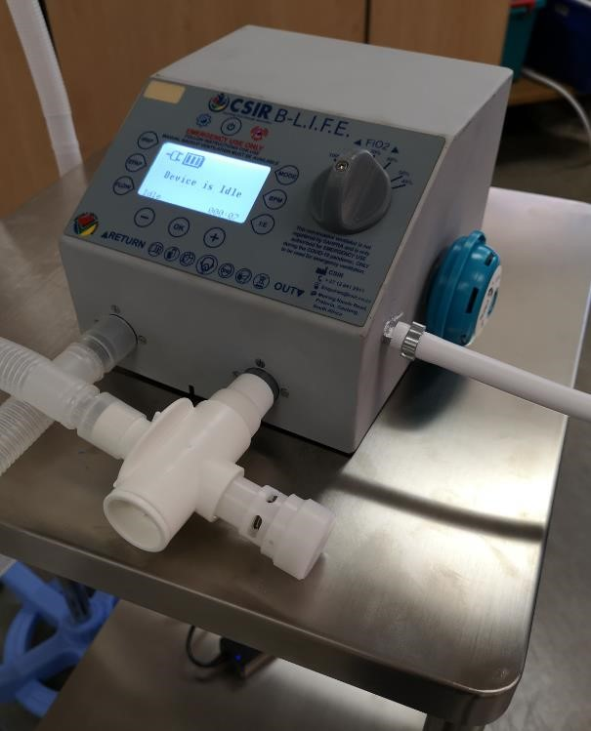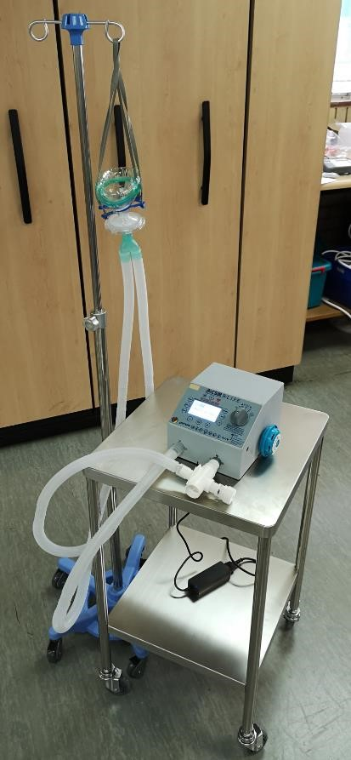

The BiPAP system consists of an electronic control board, enclosure, and specialized plastic components which might require 3D printing or injection moulding.

The device has a high percentage local content, and this must be retained during manufacturing of the device.

Submission requirements
To apply, please complete the attached EoI form and e-mail the PDF versions of completed forms, CV’s, BBEEE certificate /affidavit and proof of CIPC registration to tender@csir.co.za.
Please use the following naming convention for attached documents:
Application: | CV’s, Certificates etc:
Name of Enterprise_EOI | Name of Enterprise_CV Jane Doe  Name of Enterprise_CIPC proof of registration_

Selection Criteria:

3.1 General
Selection Criteria | Weighting | Score
Company Track Record  Have manufactured similar devices and are exporting– 80 to 100  Have manufactured similar devices and distributing locally– – 60 to 79  Have product manufacturing experience – 40 to 59 | 50%
Transformation and BBEEE (5)  Highest scoring for Ventures owned by Black Females (100) with proposals targeted at Job creation for previously disadvantaged groups.  Ventures owned by other designated groups (80) Other (50) | 20%
Business Readiness  Venture already has working capital and a competent management team (80 to 100)  Competent management team in place but requires capital to exploit the business opportunity – 60 to 79 Other (40) | 30%

3.2 Manufacturing
Selection Criteria | Weighting | Score
Current Regulatory Status and Compliance  Have valid ISO 13485 certification and have done CE marking/FDA approvals – 80 to 100  Have valid ISO 13485 certification – 60 to 79  Have valid ISO 9001 certification – 40 - 59 | 30%
Established and localised supply chain  Local production and supply chain – 80 to 100  Local production but supply chain not fully localised – 60 to 79 Intermediaries (0) | 30%
Job Intensity  >20 direct jobs created/sustained – 80 to 100  >10 direct jobs created/sustained with high proportion of highly skilled – 60 to 79  <10 direct jobs created/sustained – 40 to 59 | 20%
Digital Transformation | 20%
Automated, real time production data capturing and QA systems in place (80 to 100)
Manual systems in place for real time monitoring. Data uploaded to electronic production and QA systems at end of shift (60 to 79) No electronic systems in place (40 to 59)

3.3 Distribution
Selection Criteria | Weighting | Score
Distribution to Markets  Local and International distribution footprint – 80 to 100  Only local distribution footprint – 60 to 79  Have not distributed to Health Market – 0 to 59 | 70%
Digital Transformation/ Tracking and Tracing  Digital and real time tracking systems in place (80 to 100) Manual systems in place for real time tracking. Data uploaded to digital platform in a batch type process (60 to 79) No tracking systems in place (40 to 59) | 30%

3.4 Support
Selection Criteria | Weighting | Score
Product Support Capability  Product can be supported globally– 80 to 100  Product can be supported locally – 60 to 79  Need to establish and train product support team – 40 to 59 | 70%
Digital Transformation/ On-line Support  Online support platforms for digital content and call-centre already established (80 to 100)  Online support platforms for digital content in place but no call centre capability (60 – 79)  No existing digital support capability (40 – 59) | 30%

Reporting requirements
Successful applicants will be expected to report on any jobs created as well as sales of products. Evidence of both jobs and sales will be required, the format of which will be established during contracting.

Successful bidders may be invited for a more detailed interview.

Please e-mail PDF versions of completed submission forms to: tender@csir.co.za
Enterprise name:
CIPC registration number
Contact person(s): | Name and surname:  Position in enterprise:
Contact details | E-mail:

Landline:
Cell number:
Physical address of enterprise:

Postal address of enterprise:

Ownership arrangement |  | Demographic |  |  | Gender
 |  | Black |  | White | M | F
Directors/members
Years in business
Annual Revenue (if any)
Number of current employees | Permanent: Temporary:
Applicable manufacturing sector: (E.g., Automotive, Aerospace, Capital Goods etc.).
BBEEE status level |  |  | Attach BBEEE  certificate/ or affidavit
ISO Accreditations |  |  | Attach ISO certificate/s
Date of application:
1. Description of your core business and whether you are currently manufacturing and/or selling products as well as your current turnover
Core Business:

Current status of manufacture and scale at which manufacturing:

Current turnover:

2. Your description of the potential market need addressed by the CSIR B-LIFE product and the potential market size (try and be as specific as possible)
Market Need:

Market Size:

Route to market (identified or already in place?):

3. Detail for the provided service/s you wish to offer, what differentiates you from other service providers.
4. Description of the Quality Assurance process and relevant digital technology you use or plan use to deliver the service offered

5. What are the expected target markets that you are able to deliver the service offering to and the development time to have a full service offering for the B-LIFE ventilator in that market (i.e., time for industrialisation or development of marketing material or development of logistics partners, etc)?
6. Describe your distribution footprint for your expected markets and/or describe how you intend distributing and supporting the product in the expected markets
7. Given an assumed volume of 5000 units yearly, please indicate the potential social and economic impact of the proposed service offering, specify planned revenue for your company over 5 years.
8. Given an assumed volume of 5000 units yearly, please indicate job creation/sustainment potential of the service offering to your business.
Type of job |  |  |  | Number |  | By when
Existing/Sustained permanent jobs (permanent jobs currently in the enterprise.
Direct permanent jobs (permanent jobs to be created in the enterprise)
Direct temporary jobs (temporary jobs to be created in the enterprise)
Indirect permanent jobs (permanent jobs to be created in the value chain, i.e., supply distribution, maintenance, packaging etc.)
Indirect temporary jobs (temporary jobs to be created in the value chain, i.e., supply distribution, maintenance, packaging etc.)
Other jobs to be created (specify)
9. Please list all sources and value of business support funding received to date.
Source  (E.g. TIA, IDC, Government,  venture capital, incubator support  etc.) | Programme | Nature of support  (funding/training/mentorship etc.) | Value of support if known |  | Period of support
10. Are you currently incubated/supported by any other incubator, enterprise supply chain development programme etc.? Please specify support being received.
11. Please attach short resumes/CV’s (1/2 page each) of key personnel in your enterprise

- Team composition (both business/technical management; if not identified, proposed):
List your team: What is the team’s background, expertise & experience (business & technical)
Name | Highest academic  qualification | Position in proposed entity | Previous business management/technica l positions/experience | Previous experience in proposed Medical Instruments business area

- Support requirement:
Specify what support is needed from the Centre, if any, for you to execute on your service offering

4 ELIMINATION CRITERIA
Proposals will be eliminated under the following conditions:
- Submission after the deadline;
- Proposals submitted at incorrect email address

- Applicants’ enterprise must be registered with the CIPC and proof of registration must be provided with the application or be excluded from the process
- Applications that are not accompanied by CV’s will be excluded
- Incomplete EOI submission form
- Applications sent to any e-mail address other than tender@csir.co.za will be excluded

5 NATIONAL TREASURY CENTRAL SUPPLIER DATABASE REGISTRATION
Before any negotiations will start with the winning bidder it will be required from the winning bidder to:
- be registered on National Treasury’s Central Supplier Database (CSD). Registrations can be completed online at: www.csd.gov.za;
- provide the CSIR of their CSD registration number; and
- provide the CSIR with a certified copy of their B-BBEE certificate. If no certificate can be provided, no points will be scored during the evaluation process.

SECTION B – TERMS AND CONDITIONS

6 VENUE FOR PROPOSAL SUBMISSION

- All proposals must be submitted electronically at: tender@csir.co.za
- If document/files exceed 30MB, multiple emails may be sent.

7 EOI PROGRAMME

The program, as currently envisaged, incorporates the following key dates:

- Issue of documents: 19 July 2021
- Last date for enquiries 23 July 2021
- Closing / submission Date: 09 August 2021
- Estimated contract duration (in months/years) To be confirmed

8 SUBMISSION OF RESPONSES
8.1 All proposals are to be clearly marked with the EOI number and the name of the tenderer
PART 1: Technical Proposal: EOI No.: 8043/09/08/2021
PART 2: B-BBEE and other Mandatory Documentation: EOI No.: 8043/09/08/2021

8.2 Proposals submitted by companies must be signed by a person or persons duly authorised.
8.3 The CSIR will award the contract to qualified tenderer(s)’ whose proposal is determined to be the most advantageous to the CSIR, taking into consideration the technical (functional) solution and B-BBEE.

9 DEADLINE FOR SUBMISSION
Proposals shall be submitted at the address mentioned above no later than the closing date of
Monday, 09 August 2021 during CSIR’s business hours. The CSIR business hours are between 08h00 and 16h30.
Where a proposal is not received by the CSIR by the due date and stipulated place, it will be regarded as a late tender. Late tenders will not be considered.

10 EVALUATION PROCESS

10.1 All proposals will be evaluated by an evaluation team for functionality and B-BBEE. Based on the results of the evaluation process and upon successful negotiations, the CSIR will approve the awarding of the contract to successful applicants.

11 ENQUIRIES AND CONTACT WITH THE CSIR

Any enquiry regarding this EOI shall be submitted in writing to CSIR at tender@csir.co.za with “EOI No 8043/09/08/2021 - For B-L.I.F.E. Manufacturing, Marketing, Distribution and Support as the subject.
Any other contact with CSIR personnel involved in this tender is not permitted during the EOI process other than as required through existing service arrangements or as requested by the CSIR as part of the EOI process.

12 MEDIUM OF COMMUNICATION

All documentation submitted in response to this EOI must be in English.

13 COST OF EXPRESSION OF INTEREST

Tenderers are expected to fully acquaint themselves with the conditions, requirements and specifications of this EOI before submitting proposals. Each tenderer assumes all risks for resource commitment and expenses, direct or indirect, of proposal preparation and participation throughout the EOI process. The CSIR is not responsible directly or indirectly for any costs incurred by tenderers.

14 CORRECTNESS OF RESPONSES
14.1 The service provider must confirm satisfaction regarding the correctness and validity of their EOI.

15 VERIFICATION OF DOCUMENTS
15.1 Tenderers should check the numbers of the pages to satisfy themselves that none are missing or duplicated. No liability will be accepted by the CSIR in regard to anything arising from the fact that pages are missing or duplicated.

16 SUB-CONTRACTING

16.1 A tenderer will not be awarded points for B-BBEE status level if it is indicated in the tender documents that such a tenderer intends sub-contracting more than 25% of the value of the contract to any other enterprise that does not qualify for at least the points that such a tenderer qualifies for, unless the intended sub-contractor is an exempted micro enterprise that has the capability and ability to execute the sub-contract.
16.2 A tenderer awarded a contract may not sub-contract more than 25% of the value of the contract to any other enterprise that does not have an equal or higher B-BBEE status level than the person concerned, unless the contract is sub-contracted to an exempted micro enterprise that has the capability and ability to execute the sub-contract.

17 ENGAGEMENT OF CONSULTANTS

The consultants will only be remunerated at the rates:

17.1 Determined in the "Guideline for fees", issued by the South African Institute of Chartered Accountants (SAICA); or
17.2 Set out in the "Guide on Hourly Fee Rates for Consultants", by the Department of Public Service and Administration (DPSA); or
17.3 Prescribed by the body - regulating the profession of the consultant.

18 TRAVEL EXPENSES

18.1 All travel expenses for the CSIR’s account, be it directly via the CSIR’s travel agent or indirectly via re-imbursements, must be in line with the CSIR’s travel policy. The following will apply:
18.1.1 Only economy class tickets will be used.
18.1.2 A maximum of R1400 per night for accommodation, dinner, breakfast and parking will be allowed.
18.1.3 No car rentals of more than a Group B will be accommodated.

19 ADDITIONAL TERMS AND CONDITIONS

19.1 A tenderer shall not assume that information and/or documents supplied to CSIR, at any time prior to this request, are still available to CSIR, and shall consequently not make any reference to such information document in its response to this request.
19.2 Copies of any affiliations, memberships and/or accreditations that support your submission must be included in the tender.
19.3 In case of proposal from a joint venture, the following must be submitted together with the proposal:
- Joint venture Agreement including split of work signed by both parties;
- The original or certified copy of the B-BBEE certificate of the joint venture;
- The Tax Clearance Certificate of each joint venture member;
- Proof of ownership/shareholder certificates/copies; and
- Company registration certificates.
  - An omission to disclose material information, a factual inaccuracy, and/or a misrepresentation of fact may result in the disqualification of a tender, or cancellation of any subsequent contract.
  - Failure to comply with any of the terms and conditions as set out in this document will invalidate the Proposal.

20 CSIR RESERVES THE RIGHT TO

20.1 Extend the closing date;
20.2 Verify any information contained in a proposal;
20.3 Request documentary proof regarding any tendering issue;
20.4 Give preference to locally manufactured goods;
20.5 Appoint one or more service providers, separately or jointly (whether or not they submitted a joint proposal);
20.6 Award this EOI as a whole or in part;
20.7 Cancel or withdraw this EOI as a whole or in part.

21 DISCLAIMER
This EOI is an expression of interest only and not an offer document. Answers to this EOI must not be construed as acceptance of an offer or imply the existence of a contract between the parties. By submission of its proposal, tenderers shall be deemed to have satisfied themselves with and to have accepted all Terms & Conditions of this EOI. The CSIR makes no representation, warranty, assurance, guarantee or endorsements to tenderer concerning the EOI, whether with regard to its accuracy, completeness or otherwise and the CSIR shall have no liability towards the tenderer or any other party in connection therewith.

DECLARATION BY TENDERER

Only tenderers who completed the declaration below will be considered for evaluation.

EOI No: ……………………………..

I hereby undertake to render services described in the attached tendering documents to CSIR in accordance with the requirements and task directives / proposal specifications stipulated in the EOI
No.………….……….. at the price/s quoted. My offer/s remains binding upon me and open for acceptance by the CSIR during the validity period indicated and calculated from the closing date of the proposal.

I confirm that I am satisfied with regards to the correctness and validity of my proposal; that the price(s) and rate(s) quoted cover all the services specified in the proposal documents; that the price(s) and rate(s) cover all my obligations and I accept that any mistakes regarding price(s) and rate(s) and calculations will be at my own risk.

I accept full responsibility for the proper execution and fulfilment of all obligations and conditions devolving on me under this proposal as the principal liable for the due fulfilment of this proposal.

I declare that I have no participation in any collusive practices with any tenderer or any other person regarding this or any other proposal.

I accept that the CSIR may take appropriate actions, deemed necessary, should there be a conflict of interest or if this declaration proves to be false.

I confirm that I am duly authorised to sign this proposal.

NAME (PRINT) ………………………….
WITNESSES

- …….……………………………

- ……….…………………………

DATE: .…………………………..

CAPACITY ……………………….

SIGNATURE …………………………….

NAME OF FIRM ………………………….….

DATE ……………………………….

