Brazil, Russia, India, China and South Africa
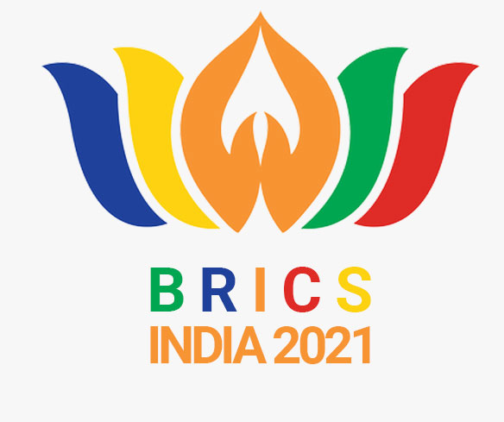

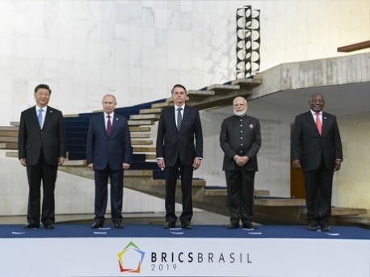 |  | 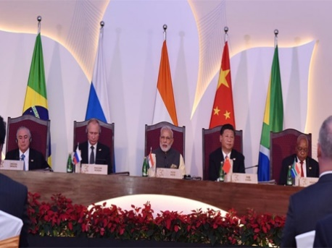
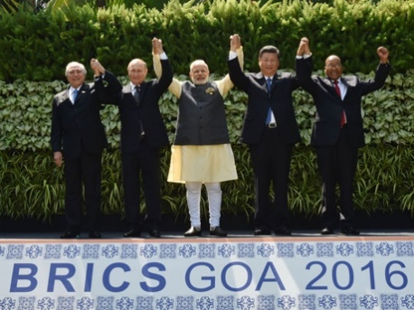 |  | 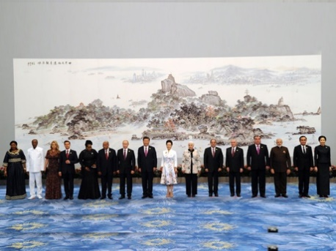

BRICS Young Scientists Forum (BRICS-YSF)
India Conclave 2021
13-16 September 2021
Building better societies through Science, Technology & Innovation

Contents

Overview

Vision

BRICS YSF Conclaves

India Conclave 2021

Programme

Themes

Participants

Eligibility

Timeline

India Conclave

Contact

BRICS Young Scientists Forum (BRICS-YSF)
India Conclave 2021, 13-16 September 2021
Building better societies through Science, Technology & Innovation

OVERVIEW
The idea of the BRICS Young Scientists’ Forum was adopted at the second BRICS Science, Technology, and Innovation (STI) Ministerial Meeting. As part of BRICS Young Scientists Forum’s activities, the first BRICS Young Scientist Conclave was held in Bangalore (India) in September 2016. Subsequently, the second Conclave was held in Hangzhou, China during (2017); third in Durban in South Africa (2019); fourth in Brasilia, Brazil (2019); and the fifth in Chelyabinsk, Russia (2020).
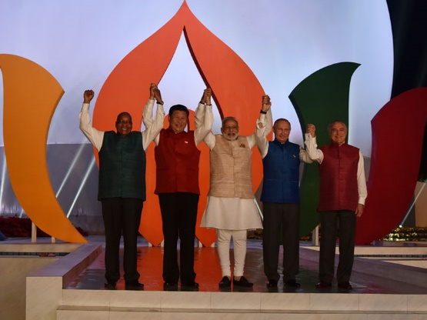
As a follow up of the above and to implement the BRICS Leaders’ declaration on “strengthening cooperation in science, technology and innovation, especially leveraging young scientific talent for addressing societal challenges; creating a networking platform for BRICS young scientists”, and to implement the instructions of BRICS ministers, in 2021, the sixth BRICS Young Scientist Conclave is schedules to take place at National Institute of Advanced Studies, Bangalore, India in September 2021. The conclave would be held in a hybrid mode – online and offline.

The Conclave will provide a high-level platform for academic and policy exchange among talented young scientists as well as scientific personnel from BRICS countries to help them grow their skills, broaden their horizon and improve academic and policy qualifications, stimulate the interest of talented young scientists in the strategic research of future technologies, direct their attention to the most promising and important field of science and technology, promote exchanges and friendship, expand channels of cooperation, strengthen inter-disciplinary integration, encourage new academic inspirations, cultivate new academic disciplines and produce valuable policy advice.

VISION
The vision of the BRICS-YSF would include the following:

- BRICS youth connectivity and networking to harness their knowledge for resolving common societal challenges through research and innovation.
- Strengthen the advancement of skill, and research competencies of youth, primarily below the age of 40 years drawn from Science, Engineering, and other allied disciplines.
- Building BRICS leadership in S&T through creative youth with capacity and capability to accelerate change individually and collectively through the Forum and through BRICS YSF alumni.
- Reinforcing BRICS countries’ and regional STI policies, youth policies, skill development and entrepreneurship policies.

LEAD SPONSORS
BRICS STI Coordinating Ministries of the BRICS countries

Department of Science & Technology from Indian side.

BRICS YSF CONCLAVES (2016-20)

The first BRICS YSF was held in Bangalore, India from 26 - 30 September 2016. The theme for the forum were Computational Intelligence, Affordable Healthcare, and Energy Solutions.

The second BRICS YSF was held in Hangzhou, China from 11 - 15 July 2017, under the theme Building Young Scientist in Leadership in Science, Technology, and Innovation. The programme was further defined under three subtheme – Energy, Materials, Biotechnology & Biomedicine.

The third BRICS YSF under the theme, Building BRICS Youth Leadership through Science, Technology, and Innovation was held in Durban, South Africa from 25 – 29 June 2018. For the first time the BRICS Young Innovator Prize, was brought into the framework. The first three award winning places were taken by the young scientist of Brazil, South Africa, and China.

The fourth BRICS YSF was held in Brasilia, Brazil from 6 - 8 November 2019. YSF was hosted under the theme Fostering BRICS long term Science, Technology, and Innovation cooperation through the partnership among Academic of Science and Young Scientists. The main thematic area was Cybersecurity, Bioeconomic, Young Innovations and Youth Entrepreneurship. The first three award wining places were taken by the young researcher of India, Russia, and Brazil.

The fifth BRICS YSF was hosted by Chelyaninshk, Russia during 21-25 September 2020 under the theme BRICS Partnership of Young Scientists and Innovators for Science Progress and Innovative growth. The main theme were Ecology, Material Science and Artificial Intelligence.

INDIA CONCLAVE 2021

The conclave will be hosted by the National Institute of Advanced Studies, Bangalore through the Zoom platform. NIAS will share the link with the selected the participants.

6th BRICS YSF Programme

The 6th BRICS YSF programme will include the following activities:

- Three Parallel Sessions on the Thematic Areas: Healthcare , Energy Solutions and Cyber Physical system (CPS) and real life applications (See following para)
- BRICS Young Innovator Prize. Thematic Areas for projects are Healthcare , Energy Solutions and Cyber Physical system (CPS) and their applications
- Networking Cafe’(youth science networking and activities)

A detailed programme would be sent a week before the Conclave.

The programme would have three days exclusively devoted to three themes chosen. Each day, there would be a keynote address on the theme, panel-discussion by senior scholars, and a panel discussion post-lunch led by the participants.

THEMES

I. Healthcare

Research in the field of healthcare has heightened significance in recent years with the advent of coronavirus and the fast-paced evolution of human lifestyle and standards of living. Healthcare research provides insights and guidance, on managing public health, challenges to healthcare and presents solutions to unanswered questions of medical science and diseases. Current advancements and developments in the field of healthcare and medical research have been possible because of continuous efforts by researchers.

New areas in healthcare research
The discipline is ever evolving, urging professionals in the field to constantly investigate and experiment with their findings. Research in this field also allows countries and international organizations to gather data and realize the gaps in healthcare systems around the world.
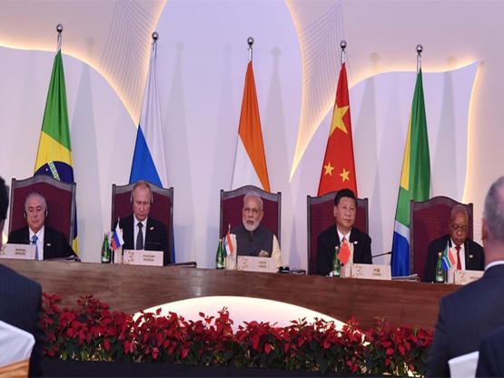
BRICS is facing serious healthcare challenges and the COVID-19 pandemic has shown the importance of coordinating health research and innovation among BRICS countries. These challenges must be met to grant everybody a long and healthy life. Ageing and the increase in chronic diseases like cancer, diabetes, heart disease, and brain conditions that require diverse types of treatment are increasing costs to potentially unsustainable levels, with the risk of unequal access to care for people across the BRICS countries.

Old and New areas/risks in healthcare
External environmental factors, including climate change, as well as the risk to lose our ability to protect ourselves against infectious diseases, for instance due to anti-microbial resistance, are also exposing us to new risks and threats. The BRICS countries are investing in research, technology and innovation to develop solutions to overcome those challenges.

In present context, the main areas of intervention for research and innovation will be focussed around following themes:
- environmental and social health determinants
- non-communicable and rare diseases
- infectious diseases including poverty-related and neglected diseases
- tools, technologies and digital solutions for health and care including personalised medicine
- next generation influenza vaccines, medicines, genomics
- health care systems,

Innovative health technologies
The aim is to find new ways to keep people healthy, prevent diseases, develop better diagnostics and more effective therapies, use personalised medicine approaches to improve healthcare and wellbeing, and take up innovative health technologies, such as digital ones.

Finally, BRICS research and innovation in health is about working together across borders, sharing each other's knowledge and resources and improving our health and care systems together.

II. Energy Solutions

The 21st Century human life depends entirely on energy on a day-to-day basis. From waking up to an alarm on a smartphone to sleeping in an air-conditioned room, one cannot live without electricity. The world has not yet found sustainable ways to conserve this energy for future generations. The conventional ways of producing energy have proved to be exceedingly harmful to the earth and have rapidly aggravated the pace of global warming, leading to climate change and other climate-related problems. It is the need of the hour to decarbonize and conduct research to find adaptable, convenient, sustainable, and cheap means to produce energy.
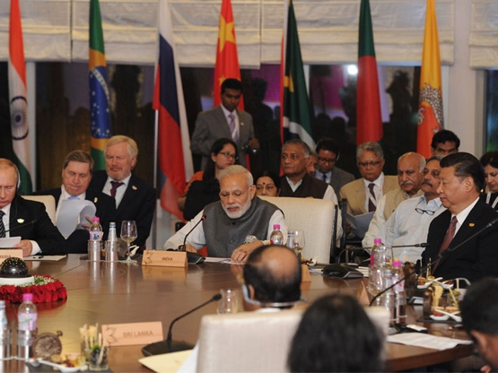
The theme on energy solutions and climate science will have the following sub-themes:
Renewable energy
According to IEAS, renewable energy makes up 26 per cent of the world’s electricity today. It includes solar, wind, hydel, tidal, geothermal, and biomass. The challenge is to make optimum use of the renewable energy, cost effective, storage and efficient distribution.

Battery technologies
The battery technology development has been varying from stagnant periods to significant breakthroughs, in an almost unpredictable fashion. The trend has been consistently directing away from heavy and acid batteries to compact, light and far more efficient nickel/metal (NiMH) accumulators.

Grid technologies
Grids help in facilitating efficient and reliable end-to-end intelligence for a two-way delivery from source to sink through the integration of renewable sources. Smart grid technologies bring efficiency and sustainability which entail the growth of electricity demand which further helps in monitoring and control of power systems, power quality management, and smart home energy system.

Innovative and Affordable research on energy solutions
New research across the world has been focusing on the innovation and affordability on energy sector. The BRICS countries need to share such ideas and explore ways and means to pursue collaborative research on making health affordable for all, through innovation.

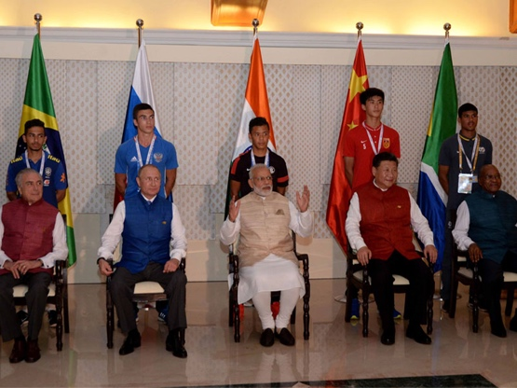
Some of these areas include the following: Renewable Energy System (RES) including Solar Energy Research; Building Energy Efficiency; Clean Coal Research; Clean Energy Material; Smart Grids Research; Methanol Economy Research; Clean Fuel Research; Hydrogen Research; and Carbon Capture, Utilization and Storage (CCUS).

III. Cyber Physical system (CPS) and their applications

CPS is the next-generation computing system under the category of embedded systems. It makes use of smart computational techniques that are related to both computational units and the physical world. This implies that CPS uses computation, communication, and controls to interact with real-world systems.

Cyber security, IoT and Data Science
The Data Science, IoT and cyber security are fundamental and basic pillars on which CPS are normally built. The economic and societal potential of such systems is vastly greater than what has been realized, and major investments are being made worldwide to develop the technology. Despite the fact that the drivers for CPS come from different sectors, the technology gaps in the sectors stem from a common set of fundamental challenges. The key cross-cutting platform technologies needed to overcome these challenges and accelerate the development of CPS applications in all sectors.

Research and Innovations in CPS
The research and innovation in this theme may cover the areas as given below but not limited to and their application in different sectors:

Modelling, Analysis and Synthesis Techniques, Mobile computing and devices for CPS, Cloud computing and distributed systems to support scalability and manage complexity of CPS Analysis, verification, and synthesis of hybrid systems, Data Science & Technologies for CPS, Simulation of CPS applications, Security and privacy of CPS, Networking systems for CPS applications Experimental prototypes of CPS’, Use case and user study of CPS, Sensors and actuators for CPS, applications Cyber-physical multimedia systems and applications, Wearable cyber-physical systems and applications, Emerging applications in CPS, including social space, crowd sourcing, art, healthcare and human computer interactions

PARTICIPANTS
21 participants from each BRICS country is expected to take part. They would include the following:
- 5 young scientists for thematic area of Healthcare
- 5 young scientists for thematic area of Energy Solutions
- 5 young scientists for thematic area of Cyber Physical system (CPS) and real-life applications
- 4 young innovators with projects under the above three thematic areas
- 1 independent jury member for the Young Innovators Prize
- 1 Head of Delegation (representative of the STI Ministry)
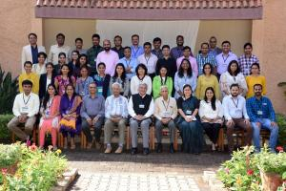

ELIGIBILITY
Scientists/ engineers/ technologists/ innovators/ science journalists/ educators-science, science literacy and popularizing professional / specialists on translational aspects of research and technology integration in society-market / researchers, up to the age of 40 years.

The participants must be doctoral students or post-doctoral or a young faculty who has completed PhD degree in the above-mentioned areas/ topics.

The applicants who have already participated in the previous editions of BRICS Young Scientist Conclaves are NOT eligible to apply.

The candidates working in private companies are not eligible to apply.

TIMELINE

26 August 2021
Final nomination from BRICS Countries

13-16 September 2021
India Conclave

ABOUT THE CONCLAVE
The Conclave would be held in Bangalore at the National Institute of Advanced Studies as on a hybrid mode. Participants from India, would take part in the Conclave in Bangalore. Rest of the participants would join the Conclave Online.

The Conclave would be held on an exclusive Zoom platform.

Links for the participants would be individually sent.

LOGISTICS

Please send applications to:
brics.competition2021@tia.org.za
Applications to be sent no later than
17 August 2021.

For further details, contact:
zipho.zwane@tia.org.za

CONTACT
For details contact the following:

Prof D. Suba Chandran
Dean, School of Conflict and Security Studies, National Institute of Advanced Studies, IISc Campus, Bangalore
Emails: subachandran@nias.res.in

Dr Arvind Kumar
Department of Science and Technology, New Delhi
Email: arvind.kumar71@nic.in

