Brazil, Russia, India, China and South Africa
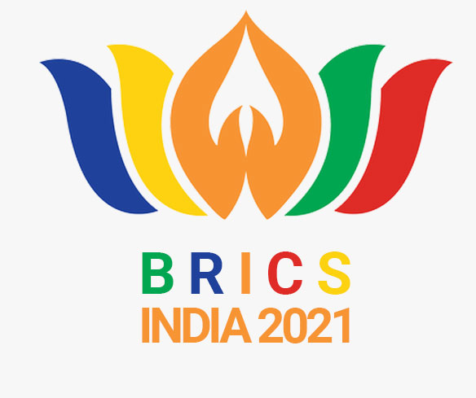

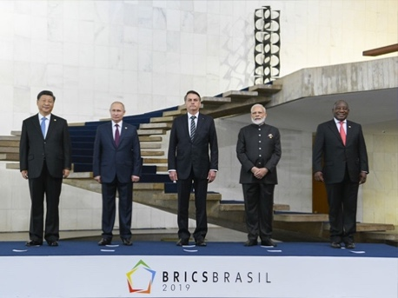 |  | 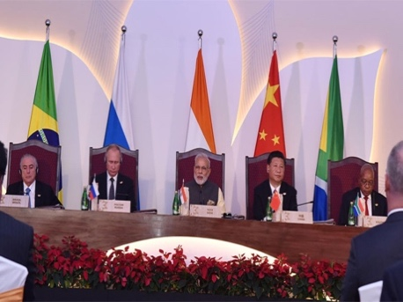
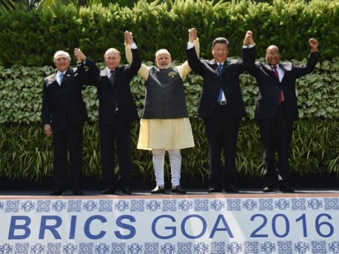 |  | 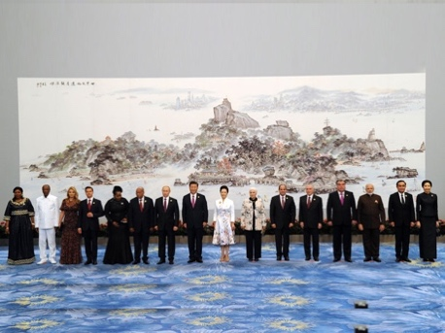

BRICS Young Innovator Prize

BRICS Young Scientists Forum (BRICS-YSF)
India Conclave, 13-16 September 2021

Building better societies through Science, Technology & Innovation
BRICS Young Innovator Prize

BRICS Young Scientists Forum (BRICS-YSF)
Rules and Regulations

About the Young Innovator Prize

The fourth BRICS Young Innovator Prize contest will be part of the sixth BRICS Young Scientists Forum that will take place 13- 16 September 2021 in Bangalore, India, under the Indian Presidency in BRICS.

The Innovator Prize is aimed to recognise and reward the best individuals related to research, development and innovation projects that represent technological innovation and a potential contribution to the science and technology sector of the BRICS countries. It is in special recognition of young talented entrepreneurs and researchers, whose outstanding innovations have made or is likely to make a profound impact on the socio-economic environment and conditions of life in BRICS societies. These young students, researchers and entrepreneurs drawn from science, engineering and allied disciplines will represent BRICS next generation scientific and technological leadership.

Requirements

The submitted projects must involve exclusive innovation.

The projects must be at the pre-market stage (not available for mass consumer acquiring, not presented as a public offer even at the local market). Projects that are at the stage of limited product testing, non-serial production, certification or preparation for launching the product on the market are accepted.

The Prize focuses on projects and prototypes that should be used to improve their respective
sectors/ industries.

There are three thematic areas for the fourth BRICS Young Innovators Prize that have been selected based on their high importance in all BRICS countries:
- Healthcare
- Energy Solutions
- Cyber Physical system (CPS) and their applications
Projects on other topics will not be considered.

The Projects should focus on major social, economic, developmental or environmental challenges and provide innovative solutions that aim to enhance conditions of life in contemporary BRICS societies. The project must be relevant minimum for 3 out of 5 BRICS countries (its actual challenges).

The volume of sales of the project presented must not exceed USD 100 000 for the last calendar year before the competition. Corporate innovations are not accepted (projects that are developed on the basis of a technology company by its employees). Also, the project should not be merged with any other technology company and not be in the process of being merged at the time of participation in the contest.

Participation in the BRICS Young Innovator Prize contest implies a participant’s agreement that the Terms and Conditions stated herein are binding on him/her.

Eligibility Requirements
Candidates to the BRICS Young Innovator Prize must be under the age of 30 (on 1 September 2021) to be eligible for participation. Candidates must be bound to BRICS member countries, either by nationality (born or naturalized) or by residence (persons with permanent residence visas).

Candidates may not submit more than one projects. Candidates must be the first/main authors of the project submitted.

Participation in the BRICS Young Innovator Prize will be restricted to four candidates per country from each BRICS member state, from among the young innovators taking part in the sixth BRICS Young Scientists Forum.

Each BRICS member state may conduct the national selection of the candidates on a competitive basis or through a process of nomination.

How to Submit
The projects must be submitted by the BRICS respective Ministries of Science, Technology and Innovation until 26 August 2021, according to each member’s rules, by e-mail addressed to subachandran@nias.res.in with copy to Arvind.kumar71@nic.in.

All submissions must contain the following documents:
- Application form (completed, signed and dated);
- Project description: A MS Word document consisting of not more than five pages, including not more than four pages of graphs, drawings, charts and/or illustrations, in the following format:
- Copy of identity document or passport;
Application form must contain the following information:
- A brief description of the project and its innovative component (up to 100 words);
- Problem definition the project
- Target audience of the project;
- Current indicators (over the past 2 years): what stages have been passed, what significant marks in development have been hit, what are the financial / quantitative indicators;
- Development strategy (for the next 1-2 years);
- Potential prospects of application (possible use of technology in 3 years or more);
- Current project request (what resources are needed; financial budget and for what purpose);
- The applicant’s role in the project and the total number of people in the team indicating their competencies or areas of responsibility in the project;
- Links to the website and social network pages of the project;
- Domestic / international awards / diplomas (if there are any)

All personal and project information must be submitted in English.

The e-mail with the application form, documents and archives of project must not exceed 20 Mb.

Inconsistent, incomplete or late submissions will not be accepted.

The application form cannot be changed in their respective contents after they have been sent to the Ministry.

The project description must include
- A brief description of the contestant’s innovative technology consisting of not more than six hundred (600) words, that conveys the essence of the contestant’s solution, omitting full details of technology, training and/or design;
- A detailed description of the proposed solution including an outline of how it is supposed to address a clearly defined social, economic, developmental or environmental challenge;
- An explanation of the broad outline of the proposed product in layman’s terms, stating the benefits of said solution over existing solutions.
The description alluded above may include any/all of the following resources:
- A PowerPoint presentation consisting of not more than 12 slides;
- A video of eight minutes reachable by link visualisation.
Both formats are acceptable, neither has an advantage over another when rating.

Please, note that adjudicators do not evaluate grant or investment obtainment as well as certification. Both possession and lacking are accepted, neither has an advantage over another when rating.

Selection Process

Pre-selection
The project that does not meet the requirements of the regulation, whether by format, content, incorrect category, submitted documentation or other criterion that precludes exempt analysis of plagiarism, will be disqualified at any time.

There will be a primary selection of the submitted projects by the Ministries of Science, Technology and Innovation of each respective BRICS country, which can be done on a competitive basis or through a process of nomination.

Up to four projects will be sent by the BRICS STI Ministries to the Department of Science and Technology, India, which will check the prerequisites and organise the contest.

The organisers of the BRICS Young Innovator Prize contest will reserve the right to reject submissions without notice, including the cases supplying false registration information and/or non-compliance of the Terms and Conditions or the guidelines of the BRICS Young Innovator Prize contest.

There is no legal recourse possible against the decision of disqualification. The adjudicators’ decisions including both procedural and reasoning will be final and will not be open to contest or review.

The selected projects will be presented to an adjudication panel, during the sixth BRICS YSF, which will choose the winners based on the established criteria.

Presentation of applications to an Adjudication Panel
The participants will be required to make a presentation of their projects to an expert panel comprising representatives of the BRICS member states.

The presentation of the project can be edited until the day before the in-person presentation. On the eve of the day of performance the presentation file must be sent to the organizers in its final edition and cannot be changed at the day of presentation.

The presentation of each project is limited to 10 minutes.

All information provided during the presentation must be in English. Usage of translation devices or translator services is not allowed.

The presentation must be individual. Only 1 person is accepted for each presentation.

The participation in Q&A session must be individual. Only 1 person is accepted for each project. The participation of other delegates is not allowed.

Usage of paper / electronic notes / cues during the presentation is allowed. Both reading and speaking are rated equally, neither has an advantage over the other when rating.

The prototype could be demonstrated by photos, videos or in-person at the discretion of the participant. All formats are accepted, neither has an advantage over the other when rating. The lack of demonstration is allowed but can cause the loss of points by criterion "Consistency of the technical information presented: presentation of procedures that prove the technical functionality of the product or process".

The adjudication panel will comprise independent experts designated by the BRICS member states. Each BRICS member state will designate one independent expert to ensure balance, fairness and transparency in the adjudication process.

The adjudication panel will choose the winners without establishing the classification of the other candidates. It may not grant the Prize if it considers that there are no qualified projects.
Selection of Winner

Each presentation of the project will be evaluated according to the following criteria:

- Innovative impact of the project (its novelty, trending, social impact, relevance to the current challenges the society of the BRICS countries faces)- 10 points
- Short term applicability (current demand and relevance) - 5 points
- Long term applicability (prospective demand and relevance) - 2 points
- Technical feasibility (accessibility of implementation, how much the presentation displays an understanding of how to implement this technology)- 5 points
- Market feasibility (business model of the project, its applicability and advantage over competitors) - 5 points
Each adjudicator evaluates feasibility for its own local market.
- Quality of the presentation of the project (clarity, consistency of information, grammar and methodology) - 5 points

After this evaluation, an oral defence, followed by a Q&A session, will define the ranking of the winners according to the following criteria:

- Consistency between written and presented project: logic of presentation, persuasiveness, clarity and structure of information, strength of argumentation and evidence base–5points
- Consistency of the technical information presented: theoretical basis of other authors, presentation of procedures that prove the technical functionality of the product or process - 10 points
- Visioning: quality of long-term planning, how much this project can be influential in a few years - 5 points
- Project team: expertise and competences of the team members - 5 points.
- Assessment step is always 1 point.
After the presentations, the adjudication panel will have a meeting to complete the final scoring before the announcement of the winners. The decision of the adjudication panel will be final and irreversible.

Reward for Winner

Successful participants will receive the following prizes after applicable verification and subject to compliance with the rules and conditions of BRICS Young Innovator Prize contest:

First Prize: Twenty-five thousand Dollars (USD 25,000) or the currency equivalent in BRICS member states to the First Prize winner as determined by the adjudication panel of the BRICS Young Innovator Prize contest.

Second Prize: Fifteen thousand Dollars (USD 15,000) or the currency equivalent in BRICS member states to the Second Prize winner as determined by the adjudication panel of the BRICS Young Innovator Prize contest.

Third Prize: Ten thousand Dollars (USD 10,000) or the currency equivalent in BRICS member states to the Third Prize winner as determined by the adjudication panel of the BRICS Young Innovator Prize contest.

The organizers reserve the right to introduce some extra nominations (it could be either with cash prize or without it) to pursue the goal to recognize additional outstanding qualities of the projects presented as well as the innovators themselves such as the best presentation, jury’s award etc. Information about extra nominations will be provided on the opening day of the Forum.

Intellectual Property Rights

Each contestant is solely responsible for taking the necessary actions that they deem appropriate to protect their intellectual property rights, prior to filing a submission with the BRICS Young Innovator Prize organisers. Such actions may include obtaining legal counsel such as advice from an attorney or a professional experienced in intellectual property law. The Terms and Conditions of this contest do not prescribe or give preference to any specific course of action or strategy (e.g. filing for patents) as such decisions remain the business prerogative of the contestant. The BRICS Young Innovator Prize organisers disclaim any responsibility to take action to protect the intellectual property rights of any contestant.

General

By entering the BRICS Young Innovator Prize, the contestant agrees:
- That the organisers of the contest have no duty of confidentiality with respect to the materials that their submission comprises, and acknowledges that the filing of a submission and participation in the public presentation may be deemed to be the publication of their invention;
- That the organisers of the contest may publicly disclose or reproduce any part or all of the contestant’s submission as well as any presentation materials;
- That if the contestant becomes a finalist that they will not enforce any IPRs that they own or control or their solution against any person who uses this solution for their personal use;
- To waive any moral rights to materials submitted in relation to the BRICS Young Innovator Prize contest;
- That the organisers of the contest may use the place of residence, image and likeness of the contestant in publications and promotional materials. Conversely, the organisers of the contest agree that the contestant may use the description «BRICS Young Innovator Prize» in publications in relation to the contest. However, the contestant is not authorised to use the BRICS 2021 Summit logo, nor state or imply that the organisers of the contest approve or endorse the contestant or the contestant’s solution;
- That the organisers of the contest may photograph and/or create videos, and/or visual or audio-visual works of all or any part of the presentations and Q&A sessions and awarding of prizes and may use, reuse, publish and republish, display and reproduce these images in whole or in part, with or without alteration or modification, without the contestant’s inspection or approval;
- That they do not have any interest (whether under copyright or otherwise) in any of the images or any creative works incorporating those images.
Projects and documents will not be returned to the candidate and will not be considered in future calls of the Prize.

Ministries will not be responsible for proposals not received as a result of possible technical problems and network congestion.

The presentation of the registration implies the acceptance of the present Terms and Conditions by the candidates, as well as full responsibility for the information provided.

The decisions of the adjudication panel shall not be subject to appeals or challenges at any stage of the process.
The authors authorise the prize organisers to use their names and images in any type of media.

The organisers of the prize will not participate in the profits obtained from the project.

The authors of the awarded projects are protected by the right to present them in exhibitions, meetings, congresses and to allow their dissemination by the press or any other means, with or without commercial purposes.
The omissions and any doubts or situations not provided for in the rules shall be judged and decided in a sovereign manner by the organisers of the prize or by the Adjudication Panel.

More information about the Young Innovators Prize 2021 can be obtained from Prof D. Suba Chandran, Dean, School of Conflict and Security Studies, National Institute of Advanced Studies, IISc Campus, Bangaloreby e-mail: brics.competition2021@tia.org.za

